Features
- USB Type C port support Power Delivery (PD) Dual-Role
- USB Type A port support Apple5V2.4A, Diviver3, BC1.2 DCP
- Single C port support charging or discharging mode
- Seamless transition among Buck, Buck-boost and Boost operation
- Intelligent detection of USB A port plug in
- Low Quiescent Current
- Comprehensive power path management and protection
- Flexible monitoring and configuration via I²C interface

Applications
- Power tools
- Smart speakers
- Portable electronics
- Internet of Things (IoT) devices
- Handsets
- Power bank
- Industrial applications

General Description
This reference design includes a highly integrated USB PD DRP controller HUSB311, a USB Type A port controller with power switch HUSB304, a highly integrated Buck-boost charger MP2651, a buck converter MP2329, and a MCU HC32110. This reference design can support charging or discharging of a single C-port 45W PD and a USB A output 5V2.4A. The HUSB311 negotiates with a USB PD power adapter (PD source) or a USB Type C port device (PD sink). It can be set as host, device or DRP. This reference supports charging 1-4 cell batteries, also supports PD power up to 45W discharge function which depends on the battery string number and capacity. Through the I²C interface, the PD negotiation can be set up. The bus voltage, the battery voltage, the battery charging current and component temperature can be monitored in real time.

Design Resources
HUSB311
HUSB304
MP2651

Application Block Diagram and EVB Figure
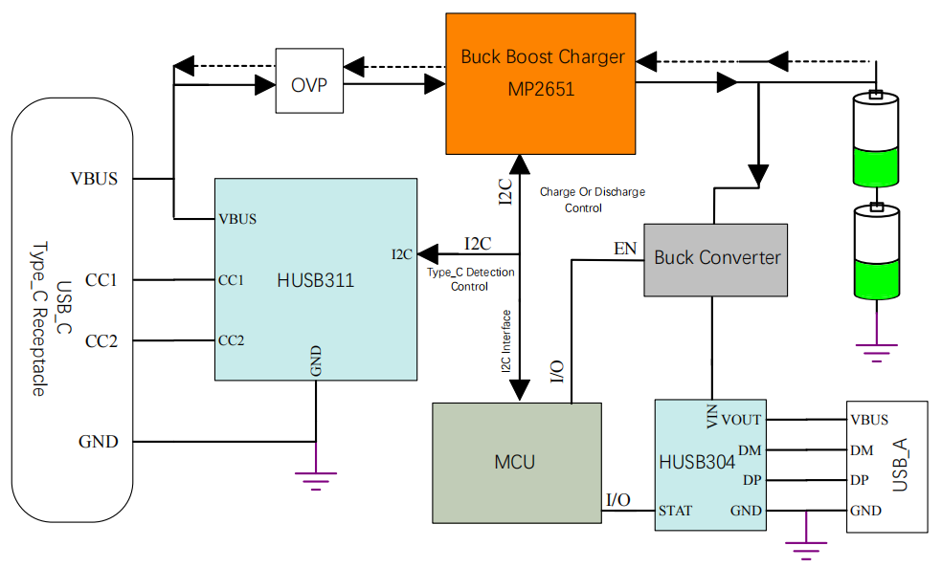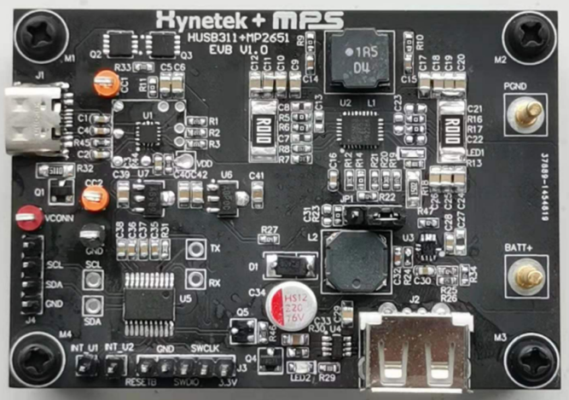

Table of Contents

Features 1
Applications 1
General Description 1
Design Resources 1
Application Block Diagram and EVB Figure 1
Table of Contents 2
Introduction 3
Design Specifications 3
Design Overview 4
Block Diagram 4
Key Products 4
Test Result 7
test Conditions 7
Test Equipment 7
Test Setting 7
Test Process 7
Test Results 7
Test Waveforms 9
Design Documents 11
Schematic 11
BOM List 12
PCB Layout 13
Important Notice 14

Introduction
This reference design is a power management solution with MCU, PD PHY HUSB311 and a buck-boost charger MP2651, which features PD 45W fast charging and discharging function through a single Type-C port, and additionally includes a USB-A port to output 5V2.4A.
The PD PHY HUSB311 with the MCU build a Type-C port manager, also called TCPM. Due to the TCPM, this EVB can automatically switch its role as host, device or DRP according to the type of the electronic product that the Type-C accesses. According to the number of battery strings and battery capacity used by the user, this evaluation board can achieve up to 45W PD fast charging and discharging function, and it can output 5V2.4A through the USB-A port to charge the mobile phone, which is very suitable for power bank or power tool applications, Meanwhile, when the USB-A port is not plugged into the device, the DC-DC step-down converter will not work, which ensures that the standby power consumption of the system is very low. Without any external power MOSFET, single Type-C port supports charging and discharging function makes the overall design materials streamlined, and the cost is reduced.
Furthermore, both the HUSB311 and the MP2651 integrate I²C interfaces as slave devices. The monitoring and advanced configurations can be achieved through the microprocessor communicating via the I²C interface, such as monitoring of the source capacity of PD power source, the negotiated PDO through the HUSB311. With I²C interface of the MP2651, the MP2651 can be flexibly programmed the charging parameters, such as input current limit, input voltage limit, charging current, battery full regulation voltage and so on. It can also provide the status and faults in operation through registers.

Design Specifications
The reference design shows how a USB Type-C PD DRP controller combined with a battery charge management system can efficiently charge 1-4 cell batteries or charge laptop or mobile phone with a large-capacity battery pack . This design can be used for power tools, IoT devices, power banks and portable electronics. The biggest advantage of this reference design is that, with USB PD negotiation, it can achieve PD 45W fast charging and discharging function through a single Type-C port.
Table1.
PARAMETER | SPECIFICATIONS | DETAILS
EVB Type-C as sink
PD sink capabilities | 5V-20V | VBUS from Type-C input
Cell configurations | 1 cell - 4 cells | Battery cell number
Charge current | Up to 3A, up to 45W | Battery charging power
EVB Type-C as source
PD source capabilities | 5V3A, 9V3A, 12V3A, 15V3A, 20V2.25A | VBUS from Type-C output
Cell configurations | 2-4 cells | Battery cell number
Discharge current | Up to 3A, up to 45W | Battery discharging power
EVB USB-A Port
Output capabilities | 5V2.4A, support BC1.2 DCP | Legacy charging port

Design Overview

Block Diagram
Figure 1. RD-2009 Application Block Diagram

Key Products
HUSB311 – USB Type-C PD Controller
The HUSB311 is a USB Type-C controller that complies with the latest USB Type-C and PD standards. The HUSB311 integrates a complete Type-C Transceiver including the Rp and Rd resistors. It does the USB Type-C detection including attach and orientation. The HUSB311 integrates the physical layer of the USB BMC power delivery protocol to allow up to 100W of power and role swap. The BMC PD block enables full support for alternative interfaces of the Type-C specification.
Key features of HUSB311:
- Dual-Role PD Compatible
- Attach/Detach Detection as Host, Device or DRP
- Current Capability Definition and Detection
- Cable Recognition
- VCONN Support
- Dead Battery Support
- Ultra-low Power Mode for Attach Detection
- Simple I2C Interface with AP or EC
- BIST Mode Supported
- e-fuse IP
- 9-Ball WL-CSP and 14-Lead QFN Packages
- Two I2C addresses
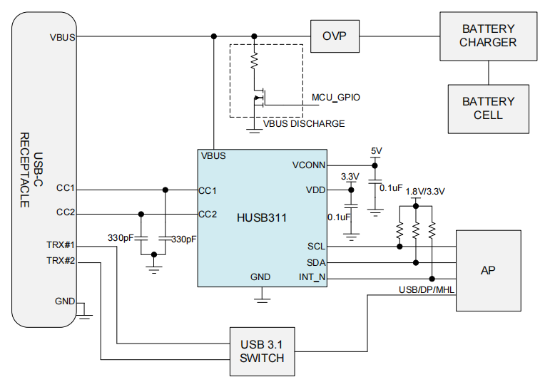
Figure 2. HUSB311 Typical Application Circuit
HUSB304 – USB Type A Port Controller with Power Switch
HUSB304 is a USB port controller, which integrates common functions for a USB type A port. There is an ultra-low Rdson (15mΩ) N-channel MOSFET integrated. It is designed for a 5V USB type A port application, which requires a high current switch. The programmable current limit provides an easy way to fine-tune the current limit through an external resistor. HUSB304 can detect its load current and change its status output to notify that there is a load applied at the current USB type C port. The output voltage and output current are both monitored by HUSB304 so that it can performs an OVP, OCP, OTP. HUSB304 has Divider 3, USB DCP applying 1.2, BC 1.2 DCP and Chinese Telecommunication Industry Standard YD/T 1591-2009 protocols inside. It can automatically detect the attached devices and switch to the proper charging protocol. Only 70uA operation current is required for HUSB304 to save the standby power loss of whole system.
Key features of HUSB304:
- Integrated 15mOhm Load Switch
- Programmable Current Limit
- Low Load Current Sensing
- Automatic DPDM Detection
Divider 3 •
USB DCP Applying 1.2V •
BC 1.2 DCP
• Chinese Telecommunication Industry Standard YD/T 1591-2009
- Status Indication
- Over Voltage and Over Current Protection
- Low Operation Current
- ±8kV HBM ESD Rating for USB IO pins

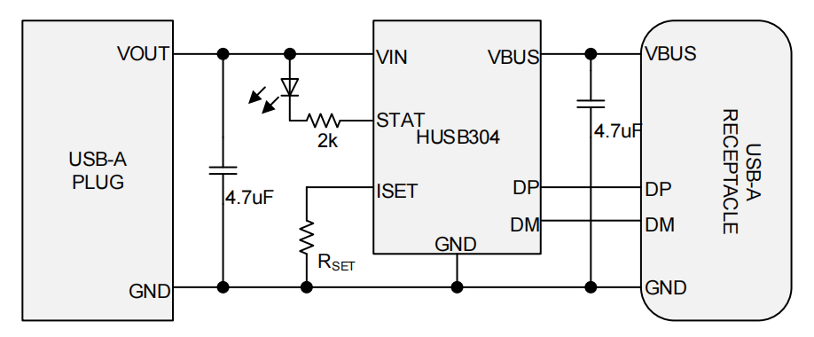
Figure 3. HUSB304 Typical Application Circuit

MP2651 – Buck-boost Battery Charger
The MP2651 is a Buck-Boost charger IC designed for battery pack with 1 to 4 cells in series. It can accept a wide range (4V to 21V) of input operation voltage for charging the battery. The battery voltage can be either lower or higher than input voltage due to the buck-boost topology. When the input is present, the MP2651 operates in charge mode. It measures the battery voltage and charges the battery with four phases: constant current trickle charge, constant current pre-charge, constant current fast charge and constant voltage charge. Other features include charge termination and auto recharge. The MP2651 also integrates the input current limit and input voltage limit to avoid overloading the input power source. This is compliant to the USB and PD specification. The MP2651 can also supply a wide range (3V to 21V) of voltage at input when source mode is enabled. It also has output current limit with high resolution in source mode. These allows the MP2651 to be compliant to the USB PD PPS.
With I²C/SMBUS interface, the MP2651 can be flexibly programmed the charging and discharge parameters, such as input current limit, input voltage limit, charging current, battery full regulation voltage, output voltage and current in source mode and so on. It can also provide the status and faults in operation through registers. To guarantee safe operation, the IC limits the die temperature to a programmable threshold. Other safety features include input over-voltage protection, battery over-voltage protection, system over-voltage protection, thermal shutdown, and a programmable timer to prevent prolonged charging of a dead battery.
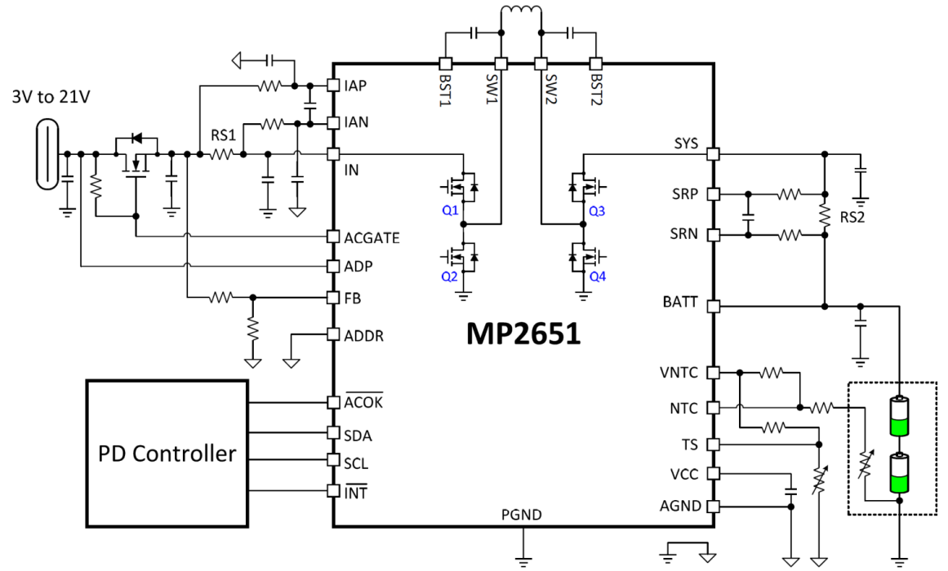
Figure 4. MP2651 Typical Application Circuit
Test Result

test Conditions
Room temperature test condition.
Input: 60W or above USB PD power adapter, or 5V3A USB-C power adapter.
Output: 1-4 cell batteries.

Test Equipment
Oscilloscope Tektronix MDO3024, Lenovo 65 W PD power adapter or 5V3A USB-C power adapter, multi-meter.
I²C interface monitoring requires additional equipment, including: a computer with USB interface, USB data lines, USB-to-I2C Communication Kit (EVKT-USBI2C-02), package Programming Tool -MP2651

Test Setting
Figure 4 shows the connection diagram of the test setup. To achieve the best evaluation performance, 60W or above PD power adapters are preferred as input power source.
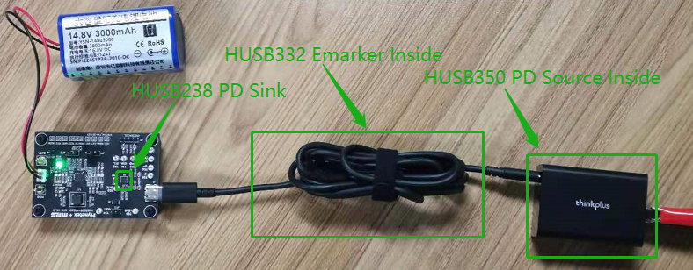
Figure4. EVB test connection diagram

Test Process
- Connect the positive electrode of the 1 to 4 cell batteries to the BATT+ pin. Connect the negative electrode of the 1 to 4 cell batteries to the PGND pin.
- The USB PD power adapter is connected to the Type-C interface of the EVB through a USB-C cable.
- Connect the oscilloscope probes to the test points of the VBUS, CC1/2, VBATT respectively. Place the current probe coil on battery positive cable.
- Apply 220V AC power source on the power adapter.
- Perform the test.

Test Results
After the circuit is connected and before the power on, the users can use the software in the computer to preset the cells and charging current of the battery through the I²C interface. The users also can preset the PDO request of the HUSB238 (in this test, we set the RDO through the VSET and ISET pins). After configuration of these parameters, then power on the PD power adapter, the users can see the HUSB238 negotiating with the PD source to request a voltage to charge the batteries. Whether the requested voltage is 5V or 20V, the 1-4 cells batteries can be charged due to that the MP2651 operates in the buck-boost topology. At the same time, the software Programming Tool -MP2651 can monitor a series of fault indications such as input voltage, battery voltage and charging current, system working mode and device temperature in real time.
Through the I²C interface the HUSB238, the monitoring functions and setting functions can be realized. Monitoring functions include: Type-C cable direction, Type-C connection state, PD negotiation response state, PD negotiated voltage and current, PD adapter Source Capabilities. Setting functions include: RDO selection, matching rules, GATE pin action, VBUS discharge time, enabling or closing support for data communication, OTP threshold VID and PID etc.

Test Waveforms
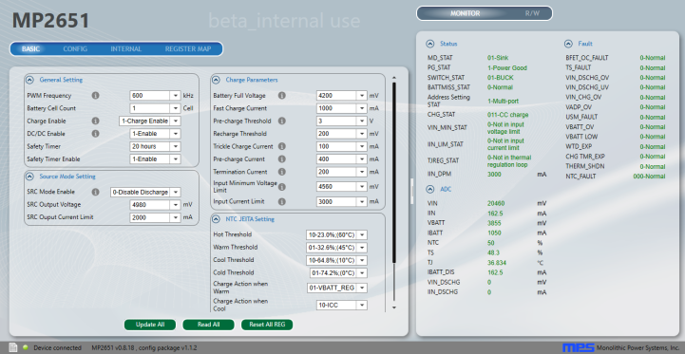  Figure 5. 1 cell charging current at 1A | 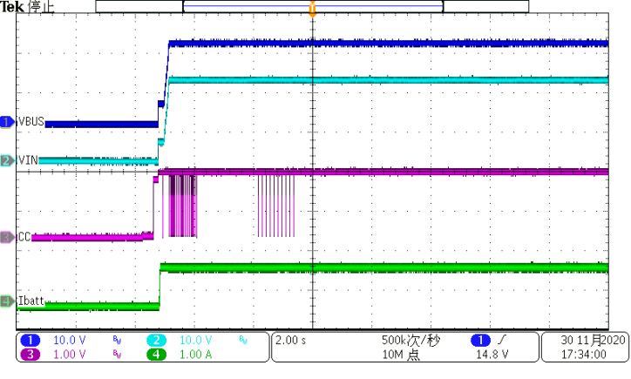  Figure 6. HUSB238 Request 20V input
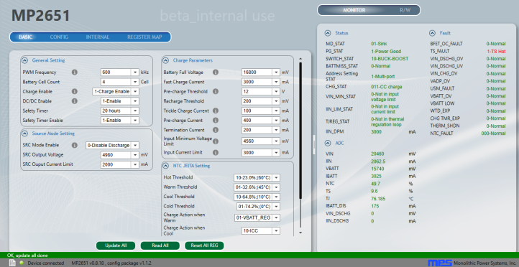  Figure 7. 4 cells charging current at 3A | 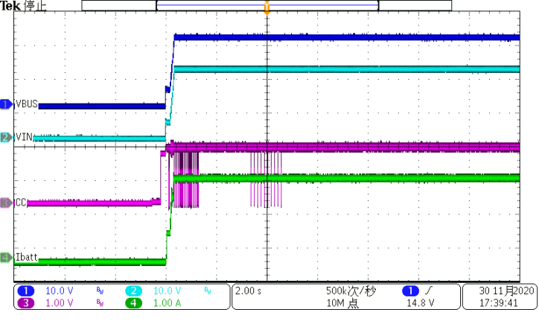  Figure8. HUSB238 Request 20V input
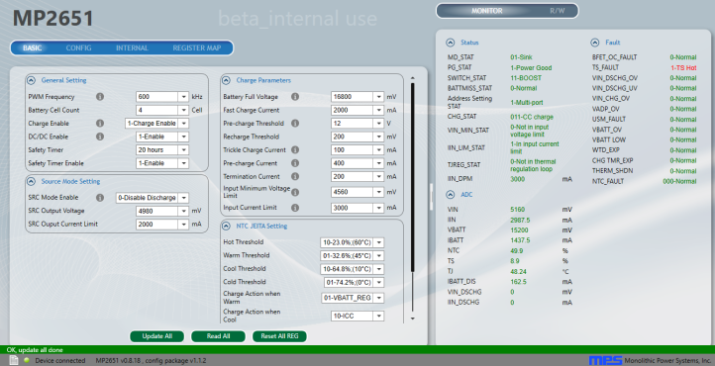  Figure 9. 4 cells charging current at 2A | 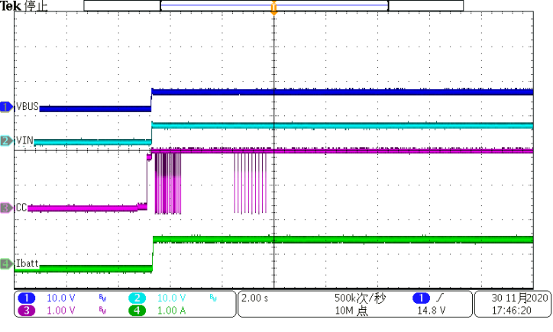  Figure 10. HUSB238 Request 5V input
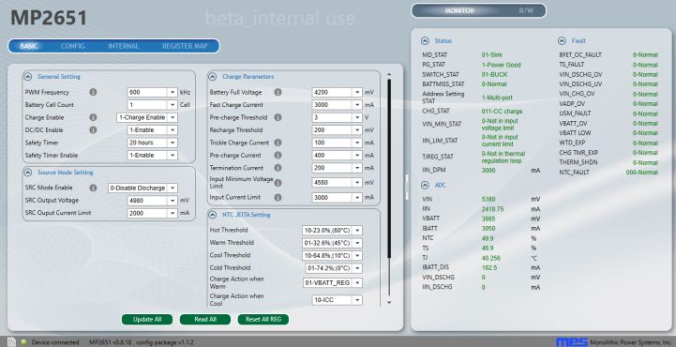  Figure 11. 1 cell charging current at 3A | 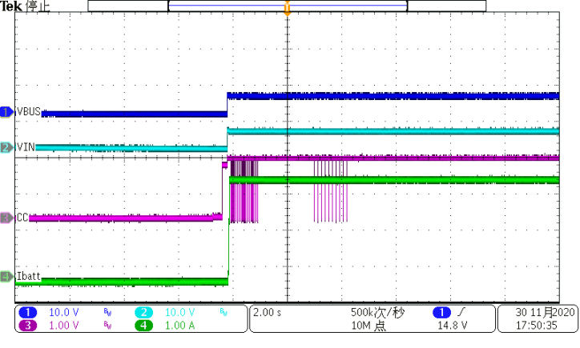  Figure 12. HUSB238 Request 5V input

Design Documents

Schematic
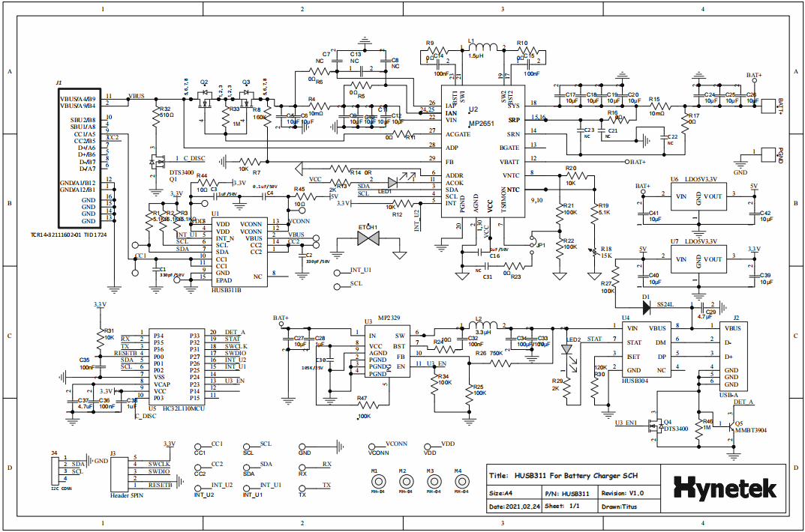

BOM List
Reference Design BOM
No. | Material Name | Specification Description | Item | pcs | Remark
Plug-in Part
1 | PCB | 72.5*50*1.6mm/1oZ | PCB | 1
2 | pin needle | Header, Male 3-pin, 2.54mm spacing | JP1 | 1
3 | pin needle | Test point 1.2pin | CC1,CC2,VDD,VCONN,GND,TX,RX,SDA,SCL | 9
4 | Connector | USB A port | J2 | 1
5 | pin needle | Header, Male 5-pin, 2.54mm spacing | J3 | 1
6 | pin needle | Header, Male 4-pin, 2.54mm spacing | J4 | 1
7 | pin needle | Connector 2.0pin | BATT+, PGND | 2
8 | Connector | TCR14-32111602-01 | J1 | 1
9 | Capacitor | 100uF/10V Solid capacitor | C34 | 1
Patch Part
10 | Resistor | 10Ω 0603 5% | R24, R44, R45 | 1
11 | Resistor | 10KΩ 0603 1% | R7, R10, R31, R12, R20 | 5
12 | Resistor | 100KΩ 0603 5% | R22, R27, R47, R21, R25, R34 | 6
13 | Resistor | 0Ω 0603 5% | R5, R6, R9, R10, R16, R17, R11, R23, R14 | 9
14 | Resistor | 5.1KΩ 0603 5% | R1, R2, R3, R19 | 4
15 | Resistor | 160KΩ 0603 1% | R8 | 1
16 | Resistor | 10Ω 0603 5% | R24, R44, R45 | 3
17 | Resistor | 750KΩ 0603 1% | R26 | 1
18 | Resistor | 120KΩ 0603 1% | R30 | 1
19 | Resistor | 1MΩ 0603 1% | R46, R33 | 2
20 | Resistor | 510Ω 1206 1% | R32 | 1
21 | NTC Resistor | 15KΩ 1206 1% | R18 | 1
22 | Resistor | 10mΩ 2510 1% | R4, R15 | 2
23 | Resistor | 2KΩ 0603 1% | R13, R29 | 2
24 | capacitor | 330P50V X7R 0603 | C1, C2 | 2
25 | capacitor | 105K35V X7R 0603 | C3, C16, C38, C28, C30 | 5
26 | capacitor | 104K50V X7R 0603 | C4 , C32, C35, C36, C14, C15 | 6
27 | capacitor | 106K25V X5R 0805 | C5, C6, C9, C10, C11, C12, C17, C18, C19, C20, C24, C25, C26, C27, C33, C39, C40, C41, C42 | 19
28 | capacitor | 475K35V X7R 0805 | C29, C37 | 2
29 | capacitor | NC | C21, C22, C23, C31,C7, C8, C13
30 | MOSFET | N MOSFET AD40N35 DFN3*3 | Q2, Q3 | 2
31 | MOSFET | N MOSFET DTS3400 SOT23 | Q1, Q4 | 2
32 | BJT | MMBT3904 ；SOT23 | Q5 | 1
33 | Point contact | NC | ETCH1
34 | LED indicator | BLHGE35A-AVTRB LED, Green | LED1 | 1
35 | LED indicator | BLHGE35A-AVTRB LED, Red | LED2 | 1
36 | Patch Inductance | Inductor, 1.5μH, 9mΩ, 14.5A SMD | L1 | 1
37 | Schottky Diode | SS24 SMA | D1 | 1
38 | LDO | CE6033A50P; SOT89M | U6 | 1 | Chipower
39 | LDO | CE6033A33P; SOT89M | U7 | 1 | Chipower
40 | IC | MP2651GVT QFN 4X5 | U2 | 1 | MPS
41 | IC | MP2329；FCQFN11/2X2mm | U3 | 1 | MPS
42 | IC | HC32L110MCU；TSSOP20_L | U5 | 1
43 | IC | HUSB304；SOT23-8 | U4 | 1 | Hynetek
44 | IC | HUSB311B；QFN14P250X250X80 | U1 | 1 | Hynetek

PCB Layout
Top Layer Mid Layer1
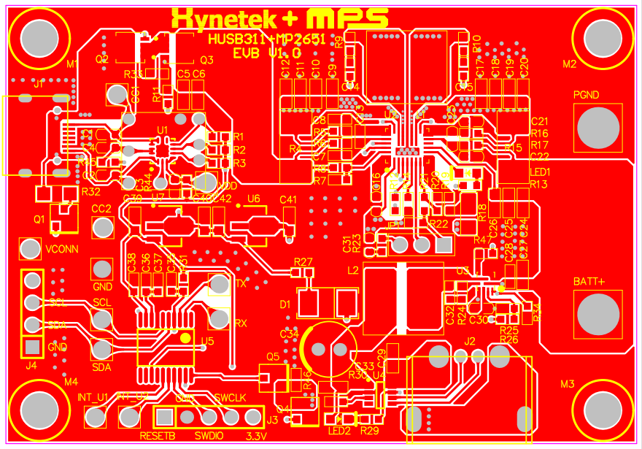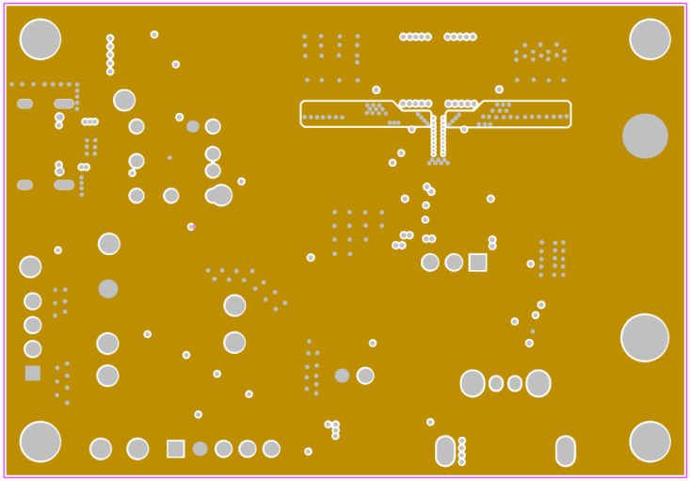
Mid Layer2 Bottom Layer
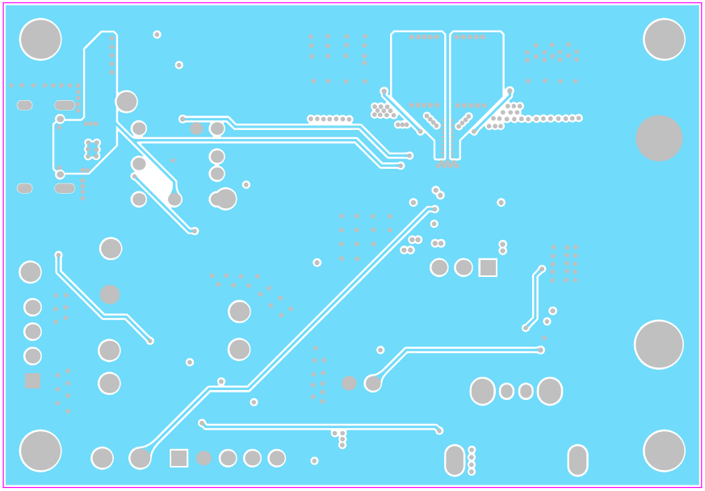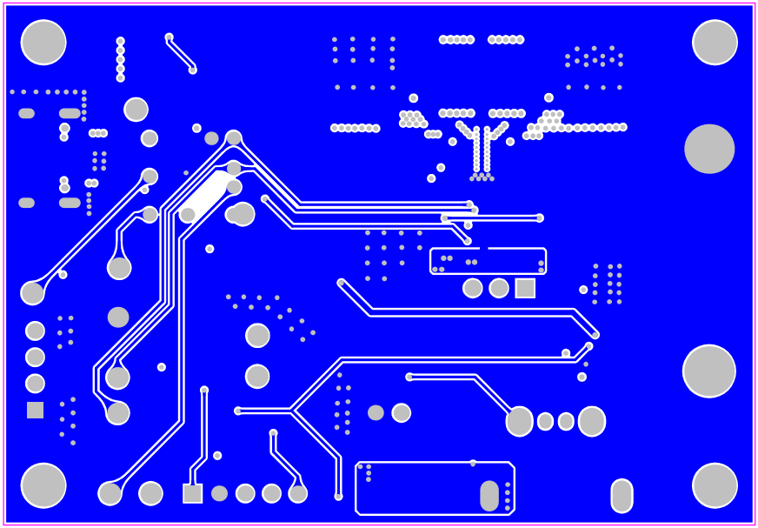
Important Notice
Hynetek Semiconductor Co., Ltd. and its subsidiaries (Hynetek) reserve the right to make corrections, enhancements, improvements and other changes to its semiconductor products and services per JESD46, latest issue, and to discontinue any product or service per JESD48, latest issue. Buyers should obtain the latest relevant information before placing orders and should verify that such information is current and complete. All semiconductor products (also referred to herein as “components”) are sold subject to Hynetek’s terms and conditions of sale supplied at the time of order acknowledgment.
Hynetek warrants performance of its components to the specifications applicable at the time of sale, in accordance with the warranty in Hynetek’s terms and conditions of sale of semiconductor products. Testing and other quality control techniques are used to the extent Hynetek deems necessary to support this warranty. Except where mandated by applicable law, testing of all parameters of each component is not necessarily performed.
Hynetek assumes no liability for applications assistance or the design of Buyers’ products. Buyers are responsible for their products and applications using Hynetek components. To minimize the risks associated with Buyers’ products and applications, Buyers should provide adequate design and operating safeguards.
Hynetek does not warrant or represent that any license, either express or implied, is granted under any patent right, copyright, mask work right, or other intellectual property right relating to any combination, machine, or process in which Hynetek components or services are used. Information published by Hynetek regarding third-party products or services does not constitute a license to use such products or services or a warranty or endorsement thereof. Use of such information may require a license from a third party under the patents or other intellectual property of the third party, or a license from Hynetek under the patents or other intellectual property of Hynetek.
Reproduction of significant portions of Hynetek information in Hynetek data books or data sheets is permissible only if reproduction is without alteration and is accompanied by all associated warranties, conditions, limitations, and notices. Hynetek is not responsible or liable for such altered documentation. Information of third parties may be subject to additional restrictions.
Resale of Hynetek components or services with statements different from or beyond the parameters stated by Hynetek for that component or service voids all express and any implied warranties for the associated Hynetek component or service and is an unfair and deceptive business practice.
Hynetek is not responsible or liable for any such statements.
Buyer acknowledges and agrees that it is solely responsible for compliance with all legal, regulatory and safety-related requirements concerning its products, and any use of Hynetek components in its applications, notwithstanding any applications-related information or support that may be provided by Hynetek. Buyer represents and agrees that it has all the necessary expertise to create and implement safeguards which anticipate dangerous consequences of failures, monitor failures and their consequences, lessen the likelihood of failures that might cause harm and take appropriate remedial actions. Buyer will fully indemnify Hynetek and its representatives against any damages arising out of the use of any Hynetek components in safety-critical applications.
In some cases, Hynetek components may be promoted specifically to facilitate safety-related applications. With such components, Hynetek’s goal is to help enable customers to design and create their own end-product solutions that meet applicable functional safety standards and requirements. Nonetheless, such components are subject to these terms.
No Hynetek components are authorized for use in FDA Class III (or similar life-critical medical equipment) unless authorized officers of the parties have executed a special agreement specifically governing such use.
Only those Hynetek components which Hynetek has specifically designated as military grade or “enhanced plastic” are designed and intended for use in military/aerospace applications or environments. Buyer acknowledges and agrees that any military or aerospace use of Hynetek components which have not been so designated is solely at the Buyer's risk, and that Buyer is solely responsible for compliance with all legal and regulatory requirements in connection with such use.
Hynetek has specifically designated certain components as meeting ISO/TS16949 requirements, mainly for automotive use. In any case of use of non-designated products, Hynetek will not be responsible for any failure to meet ISO/TS16949.
Please refer to below URL for other products and solutions of Hynetek Semiconductor Co., Ltd.
©2020 Hynetek Semiconductor Co., Ltd. All rights reserved.
Trademarks and registered trademarks are the property of their respective owners.
www.hynetek.com

